Who Am I? Navigating Teen Identity, Belonging, and Peer Pressure
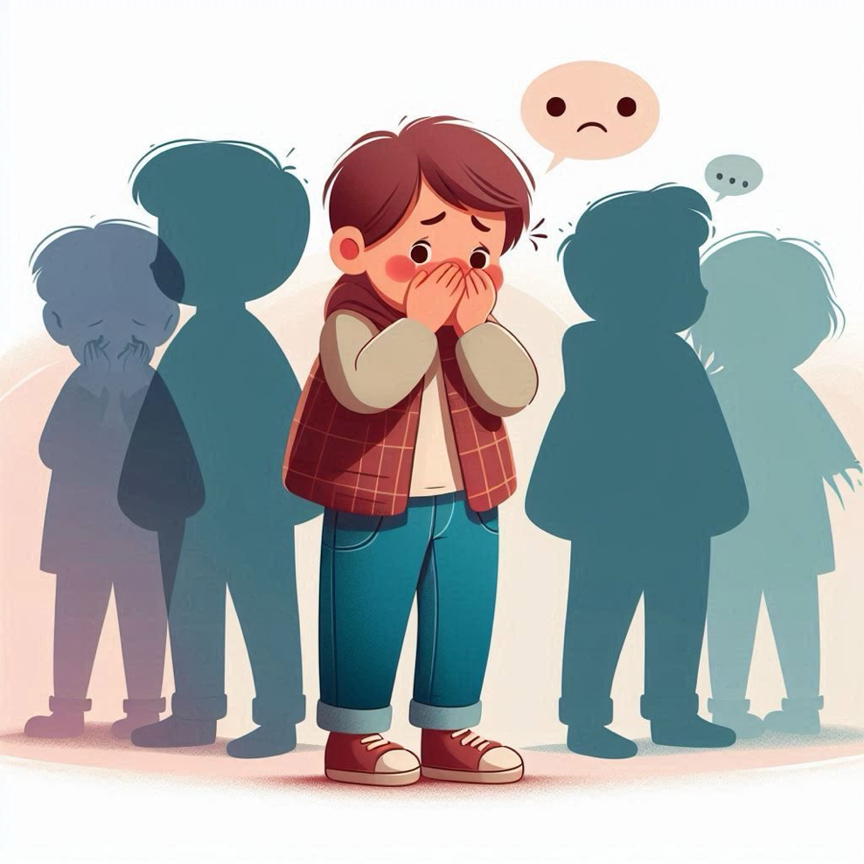

Welcome back to the Ikigai Teen blog, a space dedicated to exploring the real, raw, and often overlooked journeys of today’s teenagers. We’re here to support the vital role parents play in shaping their emotional world.
In our last post, we delved into the digital lives of our teens. Today, we go deeper into the very heart of adolescence: the quest for Identity, Belonging, and Peer Pressure.
During these formative years, every teenager is grappling with fundamental questions: “Who am I? Where do I belong? And what if I don’t fit in?” In that space of uncertainty, the voices of peers can often feel louder and more influential than the voices of parents. Let's explore how we can navigate this complex emotional landscape together.

The Quest for Identity: A Necessary Mess
First, a crucial reminder: when your teen seems to argue with everything you say, they are often not rejecting you—they are discovering themselves.
Adolescence is an identity construction zone. It’s noisy, messy, and experimental, but it is an absolutely necessary phase of development. A 2024 Psychology Today report revealed that nearly 72% of teens feel confused about "who they are"because they are constantly adapting to different environments—home, school, social media, and various friend groups. They are juggling multiple selves: one for their parents, another for their peers, one for their teachers, and yet another for the internet.
So when we worry and say, “My child has changed so much,” the truth is, they are simply evolving. They are trying on different versions of themselves until they find one that feels authentic.
Think of it like shopping for the perfect pair of jeans. Your teen is in a trial room, trying on different identities until they find the one that doesn’t pinch their confidence or sag under pressure.

The Deep Need to Belong
In the teenage brain, the need to belong is not just a desire; it’s a powerful, primal drive. It activates the same reward centers as food or pleasure. Consequently, when a teen feels excluded, the pain they experience is not just emotional—it’s neurological.
Research from the University of California shows that social exclusion in teens triggers the same brain regions that process physical pain. That’s why being left out of a group chat or being unfollowed online can genuinely hurt.
The danger is that when a true sense of belonging is missing, teens will often borrow an identity to fill the void. If they don’t feel seen and accepted at home, they will mirror their friends. If they don’t feel valued in the classroom, they will chase validation from online tribes. In that process of imitation, they can easily lose their inner compass.
Parents, your home is your teen’s first and most important belonging space. It doesn’t need to be the fanciest or the trendiest—it just needs to be the safest.

Peer Pressure in the Digital Age
Peer pressure today is not what it used to be. It’s no longer just about someone offering a cigarette behind the school building. It’s more subtle, pervasive, and digital.
It’s in the pressure to pose, post, and perform online to meet impossibly high standards of popularity and perfection. A 2023 Pew Research study found that 59% of teens feel pressure to look good online, and 40% admit to posting things they don’t really mean just to fit in.
Today’s peer pressure isn’t one loud friend; it’s a thousand silent viewers. This is why your connection is more critical than ever. When parental love is conditional—based on academic performance or perfect compliance—it puts you in competition with peer validation instead of being the anchor that complements it.

How to Help Your Teen Build a True Identity
So, what can parents do? Based on both research and practice, here are four strategies that work:
- Ask More, Label Less. Instead of saying, “Why are you acting just like them?” try asking with genuine curiosity, “What do you like about that group of friends?” This opens a door for conversation instead of building a wall of judgment.
- Model Authenticity. Teens can spot hypocrisy faster than a Wi-Fi signal. If you tell them to “just be yourself,” you must also show them what that looks like. Be open about how you handle pressure, manage friendships, and engage with the world authentically.
- Celebrate Process, Not Perfection. Every time you praise your teen's effort, resilience, or kindness instead of just their grades or achievements, you send a powerful message: their value is not tied to external approval.
- Discuss Belonging Openly. Ask them, “Where do you feel most like yourself?” Their answer will give you incredible insight into what environments feed their self-worth and which ones drain it.

A Story of Finding a "Version Worth Keeping"
I once coached a 15-year-old boy named Aarav. His personality seemed to change every few weeks—one month he was a hip-hop dancer, the next a guitar rebel, and then a debate club champion. His parents were understandably exasperated.
But when we sat down and talked, Aarav said something that has stuck with me ever since: “I just want to know which version of me is worth keeping.”
That is the profound task of adolescence. Our teens are trying to figure out which version of themselves feels worthy, accepted, and real. Our role is not to decide for them, but to create a safe, supportive environment where they can discover it for themselves.

A Mindful Check for Parents
Let’s pause for a moment of reflection:
- When was the last time you told your teen, “I really like the person you’re becoming”?
- Do they know, without a doubt, that your love is unconditional—even when their choices confuse you?
- Have you created moments at home where belonging is felt, not just spoken of?
Remember, belonging doesn’t require agreeing on everything. It means your teen knows that even disagreements can never threaten your love for them. If your teen seems more influenced by their friends than by you, don’t panic. This is a normal part of their development. Your job is not to compete with their peers but to be their emotional anchor. When things go wrong, they need to know they can come back to you.
Strong roots make for brave branches. Be the root.
Your presence is your teen’s greatest protection.

